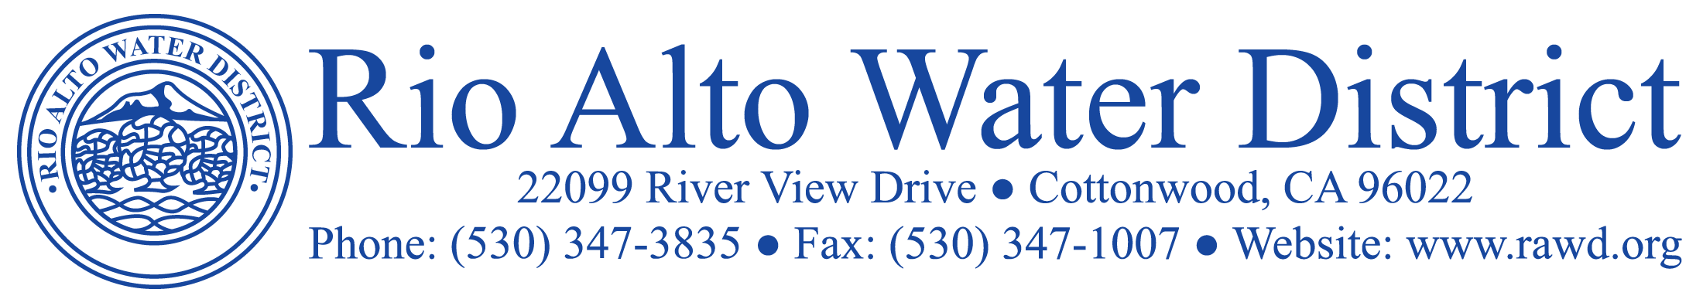

October 22, 2018

Billing Updates:
Availability bills were mailed to customers October 1, 2018 and are due by November 5, 2018 to avoid delinquent charges. Metered bills for the period of September/October will be mailed out the first week of November. If you have not received a bill by the 15th of November, please call the District. If your consumption is excessive, please call the District and we will gladly assist by checking your sprinkler timers and check for potential leaks.

Drought Updates::
Applications for turf removal rebates can still be found at turf@saveourwaterrebates.com. The precipitation total for the new water year beginning Oct.1, 2018 is .52” with a normal season to date being 1.13”. The distance from the crest of Shasta Dam is now 95.16 feet, down 13.56 feet from what was reported last month due to increased flows for agriculture and regulating water temperatures for fish. NOAA is predicting a 70 – 75% chance of a mild El Nino this winter. The bad news is that the prediction includes warmer temperatures and right now it appears the wet weather will be hitting in the southern United States.

SAVE MONEY- Pay attention to your irrigation system.
We are beginning to experience fall like weather, and as such, please take the time to reduce your irrigation timers to conserve water and save money.

Landscape Encroachment Notices:
Notices were posted to customers with landscape encroaching upon their meters. When landscaping encroaches upon the meter boxes it makes it difficult and sometimes dangerous for our field crew to read the meters. In most cases, it just involves pruning bushes around the meter box and we ask that it be completed within 30 days or District personnel will do so at the owner’s expense.

Wetlands Update:
Once again, we have received complaints about dogs without leashes at the wetlands. If this persists we will have to close the wetlands to all dogs. This is for the protection of the wildlife, your dog and yourself.

District Elections:
Remember to vote! The regular biennial election will take place on November 6, 2018. Three candidates have filed papers for the Rio Alto Board of Directors, incumbents Craig Weaver, Steve Gibbs and new candidate Mel Freimuth.

Change of Board Meeting Date:
The November Board Meeting has been moved up to November 14, 2018. Normally it would be held on November 21st but that conflicts with the Thanksgiving Holiday. Agendas, Minutes and Resolutions can be accessed at www.rawd.org under News & Notices.

Rio Alto Water District is a Special District governed by California Water Code and not affiliated with the Property Owners Association.

