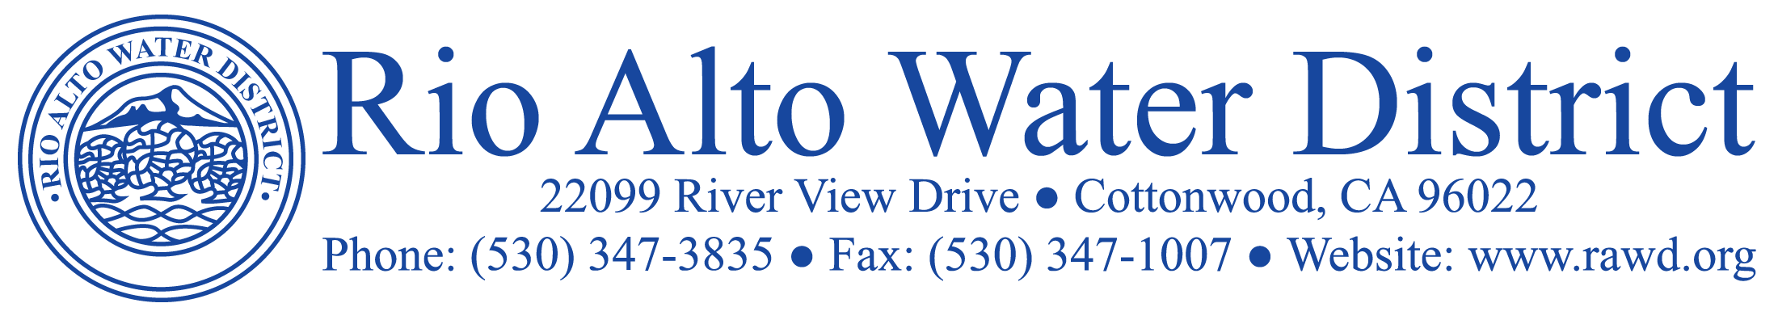

November 21, 2018

Billing Updates:
Metered billings were mailed to customers November 2, 2018 and are due by December 6, 2018 to avoid delinquent charges. Availability billings will be mailed out on December 31, 2018. Payments can be made by check, cash or card on our website at RAWD.org. Customers can sign up for auto draft payments by completing the form found on our website or at the District office.

Drought Updates::
Applications for turf removal rebates can still be found at turf@saveourwaterrebates.com. Current billing consumption was 23% lower than 2013 consumption for the same period and 24% less for the year to date total comparisons. The precipitation total for the new water year beginning Oct.1, 2018 is .52” with a normal season to date being 4.76”. The distance from the crest of Shasta Dam is now 101.55 feet from the crest, down 6.39 feet from what was reported last month due to increased flows for agriculture and regulating water temperatures for fish. Rain is predicted for the Thanksgiving Holiday, so with any luck that will be the beginning of our wet season.

SAVE MONEY- Pay attention to your irrigation system.
Please remember to turn off your sprinklers in response to rain events. Most irrigation timers have a rain setting. If and when the rains start becoming more frequent, consider turning your irrigation systems off for the winter.

Wastewater Treatment Plant:
As a reminder, please do not flush anything down your drains/toilets other than human waste, gray water and toilet paper. This can save the District and the customer costly sewer backups. Below is a picture of a recent plug from our Lift Station #1 pump consisting mainly of wipes. Imagine the homeowner cost if this got stuck in your own sewer lateral.

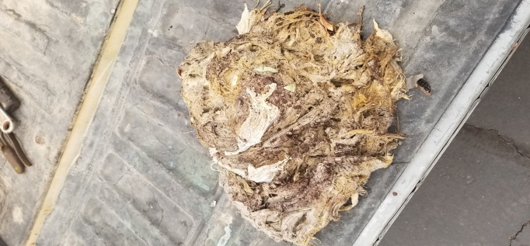
Water Quality:
Recent social media posts have questioned our water quality once again. Please note our Annual Water Quality Report can be found on our website at RAWD.org. The source of our water is very deep groundwater wells. We are very fortunate that this water is of such a high quality that we do not have to treat the water with chemicals. Weekly bacterialogical tests are performed and the District remains in compliance with all water testing and maximum contaminent levels.

District Elections:
Preliminary election results show Craig Weaver leading with 358 votes, Steven Gibbs with 332 votes, and Mel Freimuth with 285 votes. Certified election results should be received no later than December 4, 2018.

Change of Board Meeting Date:
The December Board Meeting has been moved up to December 5, 2018. Normally it would be held on December 19th, but has been changed to accommodate holiday conflicts. Agendas, Minutes and Resolutions can be accessed at www.rawd.org under News & Notices.

Rio Alto Water District is a Special District governed by California Water Code and not affiliated with the Property Owners Association.

