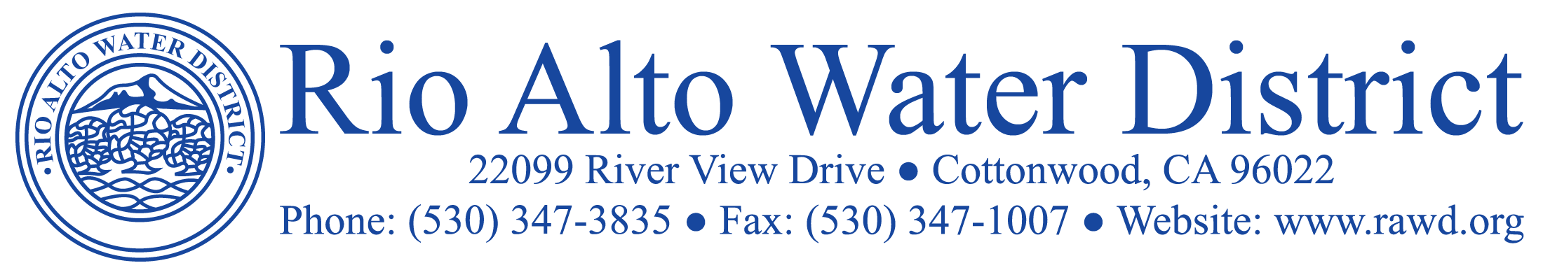

April 21, 2023

Billing Updates: Unpaid balances for the 1/3//23 -3/3/23 billing period are scheduled for lock off on June 6, 2023. 24 hour notices will be posted on the 5th. New billings for the period 3/3/23 through 5/3/23 will be mailed out on May 3, 2023 and will be subject to delinquent charges if not paid by June 6, 2023. Payments can be made by check or cash, and credit card payments can be made on our website at www.RAWD.org. If paying in person remember to bring your billing stub with you for quick and accurate posting to your account. If you pay using auto bill pay through your bank, be advised that they issue a check to Rio Alto which can take over 10 days to be received by the District. With this in mind, please allow adequate days to avoid a delinquent charge. Customers can also sign up for auto draft payments by completing the form found on our website or at the District office. This service is free and will assure payment is received before delinquent charges are assessed.

Drought: The current year precipitation numbers are very impressive with 122% of the average for the water year to date. The statewide average snowpack assessed on April 3rd recorded levels 237% of the average. They are even concerned about potential flooding with the snow melt. Shasta Lake is up 34.37 feet since last reported in March. The new totals beginning October 1st and comparisons are as follows:

Year | April 20th Precipitation Received | Average Precipitation to Date | Percent of Average | Shasta Lake feet  from Crest
22/23 | 36.32 | 29.62 | 122% | 10.45
21/22 | 17.87 | 29.77 | 60% | 123.68
20/21 | 13.27 | 30.22 | 44% | 89.28

NOAA is forecasting a 62% chance of El Nino weather conditions developing. The Governor has yet to declare the drought to be over.

Cell Tower Information: The District has negotiated a lease with T-Mobile to install an antennae on our Verizon Tower. Construction is to begin shortly, and service is predicted to be available in several months. It will be nice to have more coverage in our community.

Wetlands Update: Kudos to the wetland’s walkers, only one report of dogs off leash. On April 23rd a mountain lion was spotted in the wetlands area. Please always be alert to wildlife including rattlesnakes when walking the wetlands.

Board Meeting Date: The Board Meeting for May will be held a week later on Wednesday, May 24, 2023, 2023, at 6:30 p.m. at the District Board Room. Agendas, Minutes and Resolutions can be accessed at www.RAWD.org “Agendas” and under News & Notices.

Rio Alto Water District is a Special District governed by California Water Code and not affiliated with the Property Owners Association.

